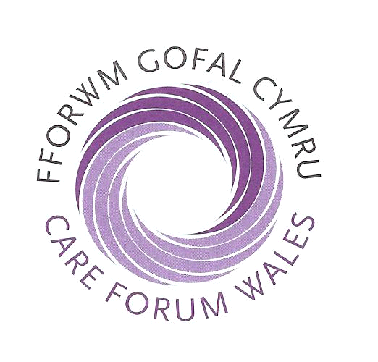

Social Care Essential Update Seminars

Our next series of Care Forum Wales Essential Updates for autumn 2018 are a must attend opportunity!
Speakers from Care Inspectorate Wales, Social Care Wales and other key agencies will provide updates on regulation and inspection, workforce registration and qualifications & employment law advice at these important twice yearly seminars providing delegates with an informative, focused and interactive day that will ensure Registered Providers, Responsible Individuals, Registered Managers and Senior Staff who are responsible for providing social care in Wales will leave the seminar with the very latest information on the opportunities that exist for your organisation to stay ahead of the rest.

The seminars provide incredible value for money as both an awareness raising and CPD learning opportunity. Seminar handout information, refreshments and buffet are included in the cost. (Certificates of attendance are available on the day by request).

Please indicate the number of delegate places required in the box for your preferred venue. All seminars will commence at 9.30am and end at approximately 3.15pm.
South East Wales North Wales
19th September 2018 20th September 2018
Village Hotel, Cardiff Optic Technology Centre, St Asaph

South West Wales
27th September 2018
Parc y Scarlets, Llanelli

Please photocopy this booking form if you require more than two places.
Name Designation

Name Designation

Name of organisation

CFW membership number (if applicable)

Address

Post code

Tel: Fax: Email

Main areas of interest (please select)

Care Home Domiciliary Care Nursing Services Dementia Mental Health

Children &Young People Learning Disability Older People Physical Disability

Education Training Other please specify _____________________________

BOOK BEFORE 15th AUGUST 2018 TO GET YOUR DISCOUNT
PLEASE CONFIRM IF YOU HAVE ANY SPECIAL DIETARY REQUIREMENTS

Cost per delegate: £35 to CFW Members (if booked before 15/08/18)
Total Remittance £__________

Cheque enclosed __________
Payable to - Care Forum Wales

Cost per delegate: £40 to CFW Members

Cost per delegate: £85.00 – Non-member (if booked before 15/08/18)
Cost per delegate: £90.00 - Non member

Details for Bacs payments as follows: RBS - Sort code-16-00-15 Account no - 23154717
Return with remittance to: Social Care Essential Update Seminars, Bromfield House, Ellice Way, Wrexham Technology Park, Wrexham LL13 7YW

PLEASE NOTE: Substitutions can be made anytime, cancellations up to twenty one days before the event will incur a £10.00 administration charge. No refund shall be given if cancellation is made less than twenty one days prior to the date of the event.

